**Question 2**

1. Bubble sort:

It is a simple sorting algorithm that repeatedly steps through the list, compares adjacent elements, and swaps them if they are in the wrong order. The pass through the list is repeated until the list is sorted. The algorithm is called "bubble sort" because smaller elements "bubble" to the top of the list.

Steps:

1. Start at the beginning of the list and compare the first 2 elements.
2. If the first element is greater than the second, swap them.
3. Move to the next pair of elements and repeat the comparison and swap if necessary.
4. Continue until the end of the list and repeat the process for the entire list until no swaps are needed.

Insertion sort:

Insertion sort builds the final sorted array one item at a time. It is much less efficient on large lists than more advanced algorithms such as quicksort, heapsort, or merge sort. However, it has the advantage of being simple and efficient for small data sets or nearly sorted lists.

Steps:

1. Start with the second element (element at index 1).
2. Compare it with the elements before it (index 0 in the first step).
3. If the current element is smaller, move it to its correct position by shifting the larger elements to the right.
4. Repeat the process for all elements in the list.

Merge sort:

Merge sort is an efficient, stable, comparison-based, divide and conquer sorting algorithm. Most implementations produce a stable sort, which means that the implementation preserves the input order of equal elements in the sorted output.

Steps:

1. Divide the list into two halves.
2. Recursively sort each half.
3. Merge the two halves to produce a sorted list.
4. I prefer merge sort because it is more efficient than both the bubble sort and insertion sort. It also provides stability as it maintains the relative order of equal elements, which can be important in certain applications. It is also consistent in its performance.
5. Bubble sort:

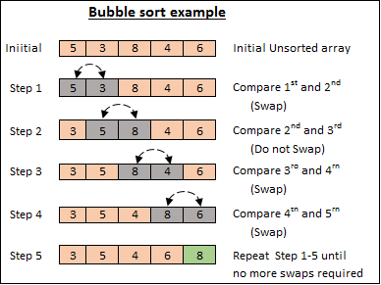

[This Photo](https://blaj2938.tistory.com/75) by Unknown Author is licensed under [CC BY-NC-ND](https://creativecommons.org/licenses/by-nc-nd/3.0/)

1. Insertion sort:

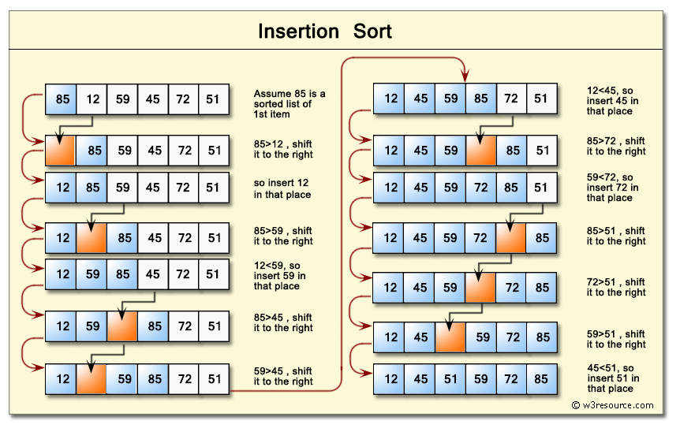

[This Photo](https://blaj2938.tistory.com/79) by Unknown Author is licensed under [CC BY-NC-ND](https://creativecommons.org/licenses/by-nc-nd/3.0/)

1. Merge sort:

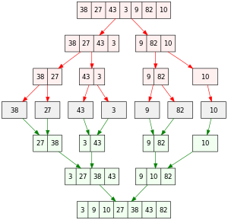

[This Photo](https://en.wikipedia.org/wiki/Merge_sort) by Unknown Author is licensed under [CC BY-SA](https://creativecommons.org/licenses/by-sa/3.0/)